**ANALYZING THE EFFECT OF CLIMATE CHANGE ON GLOBAL AGRICULTURE **

**ABSTRACT**

Climate change poses a profound and multifaceted threat to global agriculture, impacting critical components such as water availability, soil health, and crop yield. The alteration in precipitation patterns and the increased frequency of extreme weather events, including droughts and floods, significantly disrupt water resources. Changes in temperature and precipitation influence the hydrological cycle, leading to shifts in water supply and demand dynamics for agricultural activities. These alterations in water availability affect crop irrigation, leading to challenges in maintaining optimal soil moisture levels. Additionally, the changing climate exacerbates soil degradation, reducing its fertility and overall health. As a result, the intricate interplay between climate change and water and soil dynamics poses a formidable challenge to sustaining agricultural productivity on a global scale.

The impact of climate change extends to crop yield, as shifts in temperature and precipitation patterns directly influence the growth and development of various crops. Rising temperatures and altered weather conditions contribute to changes in crop phenology, affecting flowering, pollination, and maturation processes. These alterations, coupled with the increased frequency of extreme weather events, pose a threat to crop production stability. Moreover, climate-induced shifts in pest and disease patterns further compromise crop health. The intricate interactions among climate change, water availability, soil health, and crop yield create a complex web of challenges for global agriculture. Addressing these challenges requires holistic and adaptive approaches, incorporating sustainable agricultural practices, water management strategies, and the development of climate-resilient crop varieties to mitigate the adverse effects of climate change on the world's food security.

Top of Form

**Software Requirement Specification**

**Required Hardware**

* **Server Infrastructure.**
* **Database Server.**
* **Networking Equipment.**
* **Monitoring and Logging Tools.**

**Required Software**

* **Front-End Frameworks.**
* **Back-End Frameworks.**
* **Database Management System (DBMS).**
* **APIs (Application Programming Interfaces).**
* **GIS Integration.**
* **Continuous Integration/Continuous Deployment (CI/CD).**

**Data Flow Diagrams**

* This Diagram server two purpose.
* Provides an indication of how date is transformed as it moves through the system.
* Disputes the functions and sub functions that transforms the dataflow.

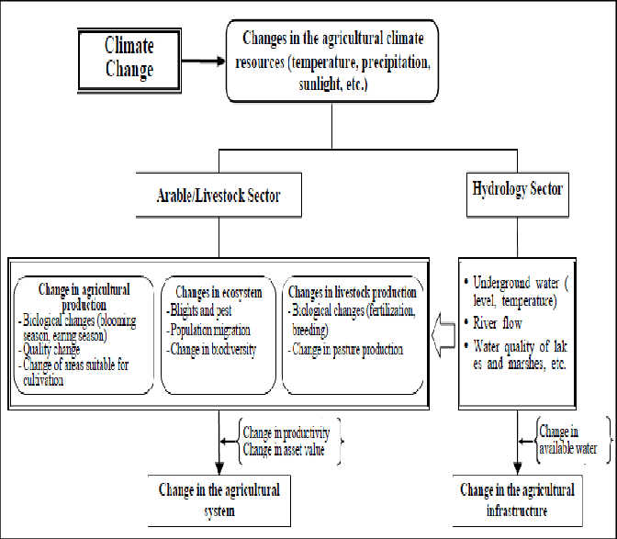

Figure no.1

**ER-Diagram**

The entity Relationship Diagram (ERD) depicts the relationship between the data objects. The ERD is the notation that is used to conduct the date modeling activity the attributes of each data object noted is the ERD can be described resign a data object descriptions.

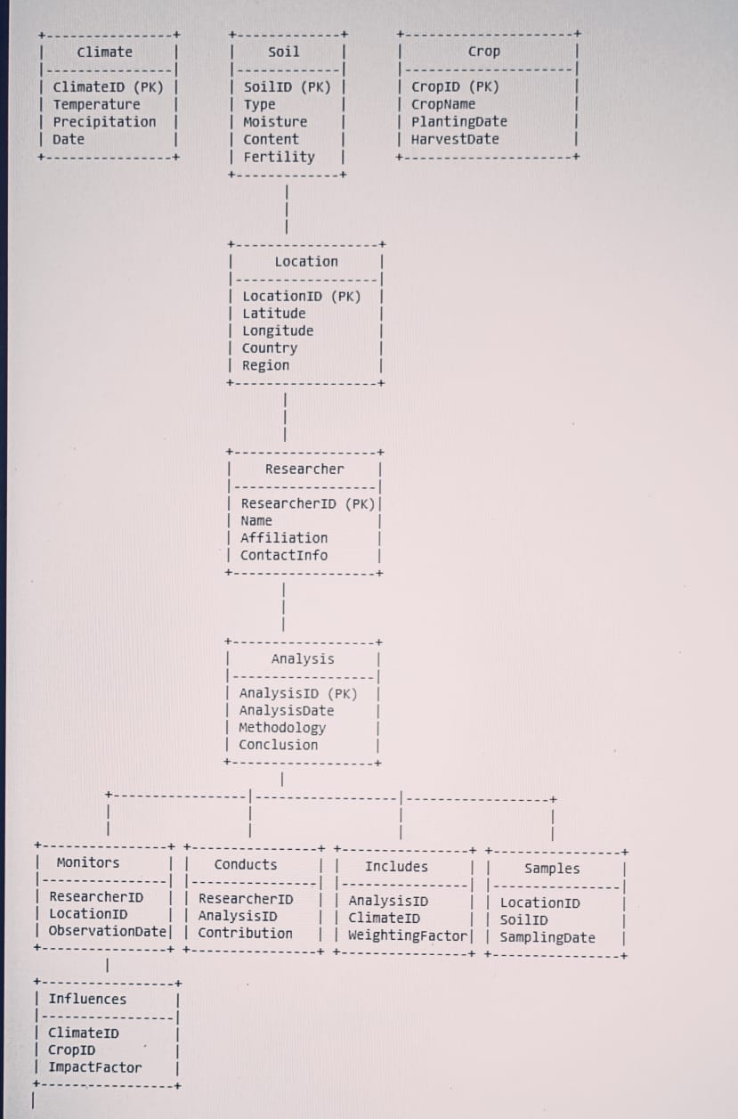

**Figure no.2**

**ADVANTAGES AND DISADVANTAGES**

Advantages:

**Informed Decision-Making:** Understanding the impact of climate change on agriculture allows for informed decision-making by governments, policymakers, and farmers.

**Risk Mitigation:** Analysis enables the identification of vulnerable regions and crops, helping to implement risk mitigation measures. This includes developing climate-resilient crop varieties, implementing water management strategies, and adopting sustainable agricultural practices.

**Early Warning Systems:** Climate analysis can aid in the development of early warning systems for extreme weather events, such as droughts or floods. Farmers and communities can better prepare for and respond to such events, minimizing the impact on crops and livelihoods.

Disadvantages:

**Global Inequalities:** Vulnerable regions, often those with less developed infrastructure and resources, may be disproportionately affected by climate change. Analyzing these effects may underscore existing global inequalities in resources and resilience, posing ethical challenges in policy development.

**Implementation Challenges:** Translating research findings into actionable policies and practices can be challenging. There may be resistance to adopting new agricultural techniques or policies, and the implementation of effective strategies may face bureaucratic and financial barriers.

**Complexity of Variables:** The interplay of various factors such as temperature, precipitation, soil quality, and crop types makes the analysis complex. The multitude of variables requires sophisticated models and comprehensive datasets, which may not always be available.

**TEMPLATE**

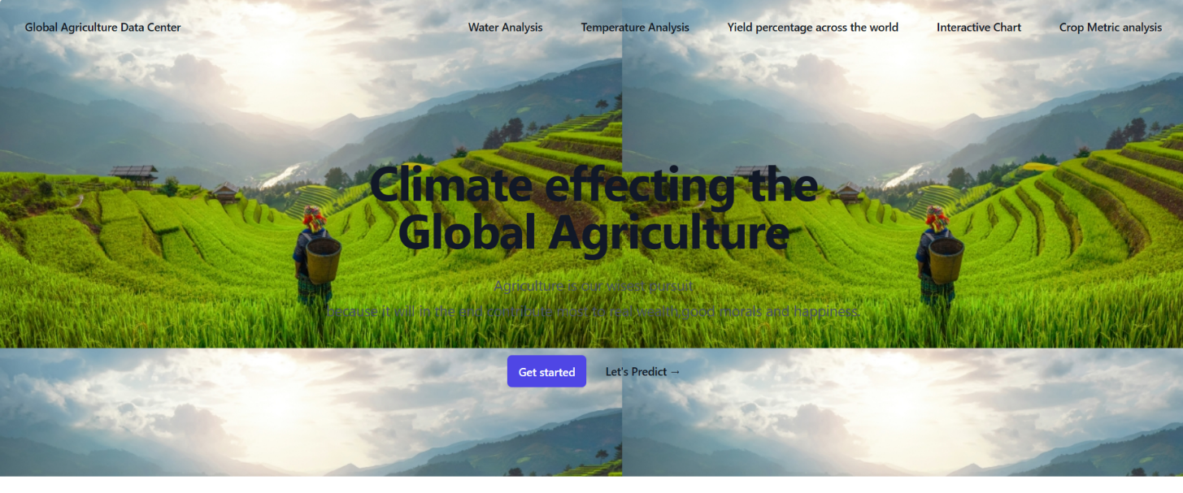 **Figure no.3**

**Figure no.4**

**CONCLUSION**

**ANALYZING THE EFFECT OF CLIMATE CHANGE ON GLOBAL AGRICULTURE** is an imperative undertaking with far-reaching implications for food security, environmental sustainability, and economic resilience. The insights gained from such analyses play a pivotal role in guiding policymakers, researchers, and farmers toward informed decision-making and proactive adaptation strategies The advantages of these analyses lie in their potential to empower stakeholders with a deeper understanding of the complex interactions between climate variables and agricultural systems. Informed decision-making allows for the development and implementation of adaptive measures that can mitigate risks, enhance resource efficiency, and contribute to the overall resilience of agricultural practices. The identification of vulnerable regions and crops, coupled with the establishment of early warning systems, enables communities to prepare for and respond to climate-related challenges, ultimately safeguarding livelihoods As the global community faces the ongoing impacts of climate change, it is crucial to recognize the importance of ongoing research and analysis in this field. The outcomes of such endeavors contribute not only to the scientific understanding of climate-agriculture interactions but also inform policies that can shape a more sustainable and resilient future for global agriculture. Embracing a holistic approach that combines scientific rigor, technological innovation, and socio-economic considerations is essential for addressing the complexities of climate change and securing the future of agriculture on a global scale.

**REFERENCES**

• <https://www.w3schools.com/html>

• <https://www.w3.org/style/css>

• <https://wikepedia.or/wiki/MySQL>

• <https://wikipedia.org/wiki/javascript>

• <https://httpd.apache.org>

• <https://w3schools.com/php>

• Learning PHP, MySQL & JavaScript: With j Query, CSS & HTML

• Java: The Complete Reference: Herbert Schildt